*Five Generations of Computers*

## *First Generation (1940-1956) Vacuum Tubes*

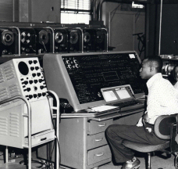

## *Second Generation (1956-1963) Transistors*

## *Third Generation (1964-1971) Integrated Circuits*

## *Fourth Generation (1971-Present) Microprocessors*

## *Fifth Generation (Present and Beyond) Artificial Intelligence*

First inventor of computer calculator Machine

The Pascaline of Blaise Pascal

17th century

First computer inventors

ENIAC was conceived and designed by [John Mauchly](http://en.wikipedia.org/wiki/John_Mauchly) and [J. Presper Eckert](http://en.wikipedia.org/wiki/J._Presper_Eckert) of the University of Pennsylvania

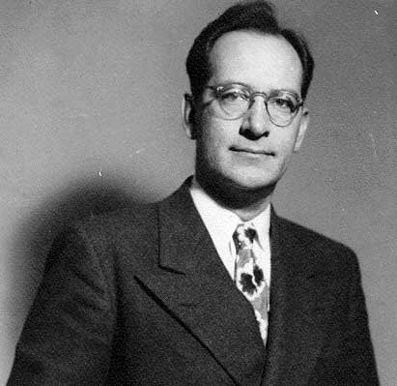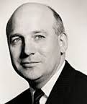

John Mauchly J.Presper Eckert

# **Father of modern computer**

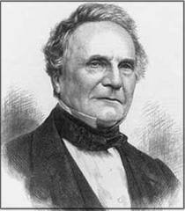

Charles Babbage

Born -> 26 December 1791 Died –> 18 October 187

Charles_Babbage_Signature

inventor of mouse of computer

Douglas Engelbart

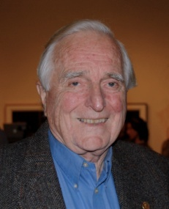

Inventor of Keyboard of Computer

Christopher Latham Sholes (February 14, 1819 – February 17, 1890)

### First Inventor Of Monitor

### Cathode Ray Tube (CRT) monitor

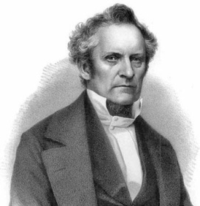

Inventor’s of internet

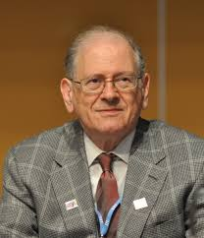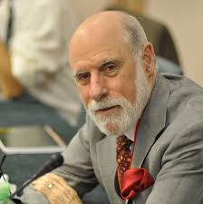

Robert E. Kahn Vint Cerf